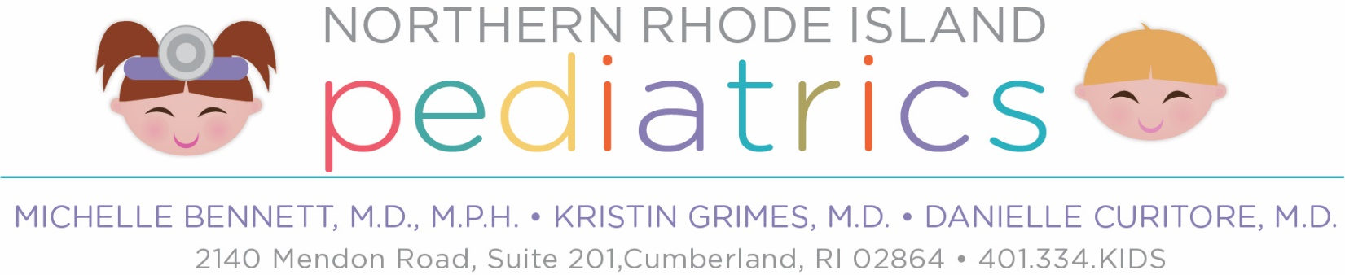
For patient’s transferring TO the practice:

Please complete the medical request form to obtain the patient’s medical record from the previous MD. In order to provide you with the best care possible, we require the COMPLETE medical record BEFORE an appointment is scheduled. Please allow up to 30 days for your prior doctor’s office to forward medical records to us. If there are concerns with the time frame of records being received, we encourage you to contact the previous office directly.

Please have records forwarded to:
NRI Pediatrics, PC
2140 Mendon Road
Ste. 201
Cumberland, RI 02864

For patients transferring FROM the practice:

To obtain a copy of your child’s medical records, please complete the enclosed medical release form and return it to the office.

Please note that there is a $15.00 processing fee for each child’s record. Additional fees may apply when a record has to be retrieved from storage, or if a record needs to be mailed. When you return the signed authorization form, we ask that you remit payment at that time. Records will not be copied until payment is received. We accept cash or credit card as methods of payment for records. If you would like to pay by credit card you may complete the credit card information section below and return this letter to us. You can also call in the payment if you prefer.

We will process your request as soon as we can, but please note that it may take up to 30 days.

We encourage you to pick up your child’s records rather than having us send them to a medical facility or office. By doing this, we avoid loss of records in the mail, and you will be able to make a copy of the records to keep for yourself. Please call the office if you have any questions.

Credit Card # (Visa or MC only): _________________________________
Exp. ______________ CVC Code: _______________
Signature of cardholder: _____________________________________
Northern RI Pediatrics
Michelle Bennett, M.D., MPH
Kristin Grimes, M.D
Danielle Curitore, M.D.
Joanne Donahue, FNP
2140 Mendon Road Suite 201
Cumberland, RI 02864
Phone: (401)334-5437 Fax: (401)334-3571
Authorization to Release and/or obtain confidential information

Patient Name: ____________________________________________ DOB: __________________
Parent or guardian’s name (if under 18):____________________________________________________
Address: _______________________________________________________________________
Phone #: ________________________ Cell: ______________________________

I hereby authorize Northern Rhode Island Pediatrics to:

Release to / Obtain from: Name: _____________________________________________________
Address: ___________________________________________________
City/ State: _________________________________________________
Phone: _________________________ Fax: _______________________

The following information: ___________________________________________________________

I understand that my records are protected under the federal confidentiality regulations of alcohol and drug abuse treatment and/or the General Laws of the State of Rhode Island. I also understand that further disclosure of this information is not admitted without my express, written authorization.
I have read carefully or have been read to and understand the above statements and voluntarily consent to disclose the above information and/or medical records to those persons/ agencies named above. This includes alcohol/ drug abuse records, mental health records and HIV (AIDS) results.
I further release Northern Rhode Island Pediatrics and its employees from any liability arising from the release of information to such persons/agencies, provided the said release of information is done substantially with applicable law.
I understand that I may revoke this consent at any future time and that it will automatically expire 90 days after it is signed or after they’ve been completed.

SIGNED: _______________________________________ Date: ____________________________
Relation to child: ____________________________

